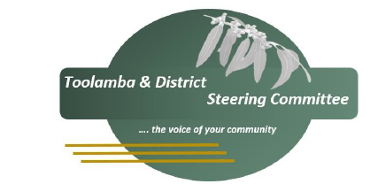

Community Group as addressed

**TOOLAMBA VIC 3614**

The Toolamba & District Steering Committee is undertaking a reviews Toolamba and District Community Plan 2023 – 2027 on Tuesday 9 September at the CFA commencing at 5.30pm.

The Plan which was developed three years ago in consultation with community groups and individuals identifies the community's future vision and goals and is the strategic document utilised by the Council, Government and other funding bodies when considering and assessing future community projects and development opportunities for Toolamba and District. The Steering Committee plays a pivotal role in driving the implementation of the plan through advocating for services and assets for our community.

As a result of the plan and the advocacy of the Committee in support of community groups and individuals funding has been made available for a range of projects, for example facilities at the Community Centre, upgrading of the tennis courts, celebration of 150 years of Toolamba Primary School, Neighbours Day event.

In addition, advocacy has led to reduced speed limits near Meadow Woods, tree planting as part of the streetscapes, facilities for the Recreation Reserve and inclusion of footpath upgrades in Council’s budget.

All members of the community are invited to attend the Review meeting and have input into the Plan and identify the changes required to reflect the current needs of the community. We look forward to welcoming individuals and community group representatives to the meeting.

Attached to the email is a copy of the current Action Plan outcomes, actions and priorities. A copy of the complete plan is available on the Shepparton Council website at <https://greatershepparton.com.au/community/neighbourhoods/community-plans/toolamba-community-plan>

Yours sincerely

Mary Coad

Secretary

Toolamba & District Steering Group

28/07/2025